AI-Based Tool For Preliminary Diagnosis Of Dermatological Manifestations

Jerrin Joe Francis
School of CSE,
Presidency University,
Bengaluru-560064, India.
jerrin.francis@presidencyuniversity.in
Vankam Viswa Sai
School of CSE,
Presidency University,
Bengaluru-560064, India.
vankam.20221cse0045@presidencyuniversity.in
Lakshmi Priya Narayan
School of CSE,
Presidency University,
Bengaluru-560064, India.
lakshmi.20221cse0374@presidencyuniversity.in
Hemanth K
School of CSE,
Presidency University,
Bengaluru-560064, India.
hemanth.20221cse0046@presidencyuniversity.in

Abstract
Skin cancer diagnosis holds significant importance in dermatological care, where timely and accurate identification greatly enhances patient outcomes. This project introduces a deep learning-driven automated system for classifying skin lesions using the HAM10000 dataset, which includes dermatoscopic images of various benign and malignant skin conditions. The framework employs a custom Convolutional Neural Network (CNN) architecture designed to extract detailed visual features of skin lesions through sequential convolution, pooling, and normalization layers. To tackle the issue of class imbalance, RandomOverSampler was implemented, ensuring balanced representation and enhanced learning stability. The system features an optimized training process with the Adam optimizer, learning rate scheduling, and regularization methods like Batch Normalization and Dropout, effectively reducing overfitting. Comprehensive experimentation and hyperparameter tuning were conducted to improve generalization and model robustness. This model was capable of achieving a very high test accuracy of 97.79% which in comparison with other existing models is very high. We have evaluated the performance of the model by calculating evaluation metrics such as precision, recall, F1 score, ROC-AUC Curve and confusion matrix which explains the performance of the model with numerical parameters. In this particular study we can notice the importance and capability of advanced concepts such as deep learning to analyze the dermatological data which helps us to perform prediction earlier than severe reaction in an effective manner.
Keywords— Deep Learning, Skin Lesion Classification, HAM10000, Convolutional Neural Network, Data Augmentation, MobileNet.

INTRODUCTION
The majorly concern in today’s world which has shook the world is skin cancer.This early detection tool is useful for patient survival and successful treatment. Conventional diagnostic techniques usually depend on visual examination by dermatologists, which can be subjective and subject to human mistakes. Therefore, the application of deep learning (DL) and computer vision in analyzing dermatological images has become a significant advancement for achieving consistent, precise, and automated skin lesion categorization.
In recent years, Convolutional Neural Networks (CNNs) have shown outstanding performance in medical image analysis due to their ability to extract intricate spatial and hierarchical features from dermoscopic images [1], [2].
Numerous studies have investigated CNN structures and ensemble techniques for skin lesion classification, achieving impressive accuracy rates. For example, stacking CNNs and hybrid deep learning models have reported accuracies exceeding 98% [1], while innovative architectures like DeepSkinNet achieved 97.35% accuracy in identifying melanoma and other lesion types [2]. Likewise, custom CNN models with balanced datasets and up-sampling strategies have consistently achieved results above 96% [3]–[5].
The model is trained to achieve highest classification accuracy of 97.79% which is comparitively higher than most existing approaches to show its effective practical application in the stream of dermatological practices.The research clearly shows the actual potential of implementation of AI in the field dermatology showing the collaboration of innovation and healthcare.

LITERATURE SURVEY
The automated classification of skin lesions using deep learning has been an active and rapidly evolving field of research. Studies have progressively focused on improving model accuracy, handling class imbalance, and developing novel architectures.
Recent work by Sharma and Reddy [1] has explored the use of ensemble stacking approaches to combine multiple models, thereby improving overall classification accuracy. Mehta et al. [2] proposed a specific deep learning model named "DeepSkinNet" for skin cancer detection. This trend of enhancing model performance was also explored by Gupta and Singh [3], who investigated various methods to improve the classification accuracy of deep convolutional neural networks. Providing a broader context, Patel et al. [4] offered a review of the different deep learning techniques being applied to skin lesion classification.
A significant challenge in this field is the severe class imbalance found in datasets like HAM10000. Kumar and Kumar [5] specifically addressed this by demonstrating the necessity of employing up-sampling and data augmentation to achieve balanced and reliable model performance. Building on this, much research has focused on applying and comparing specific architectures. Prakash et al. [6] demonstrated the high performance of the EfficientNet-B7 model, while Das et al. [10] also successfully applied EfficientNets for multi-class classification. Ali and Riaz [7] developed a hybrid system for the HAM10000 dataset, using a CNN for feature extraction and a KNN for the final classification.
Other researchers have focused on specific model families. Zhang and Park [11] investigated the use of MobileNet for its efficiency in mobile-friendly applications, and Nair and Raj [14] studied the performance of the DenseNet architecture. The general application of deep learning to the HAM10000 dataset was also successfully demonstrated by Rao et al. [12]. Broader comparative studies have also been influential; both Singh and Gupta [17] and Huang et al. [18] provided comparative analyses of different deep learning models, helping to establish performance benchmarks.
The use of transfer learning, which leverages models pre-trained on large datasets like ImageNet, has been a common and effective strategy, as shown in the work of Dasgupta and Roy [13] and Das and Dutta [20]. Other approaches include two-stage processes, such as the one by Li et al. [16], which used a UNet for lesion segmentation before classification. Foundational work by Tan and Le [19] demonstrated the efficacy of the InceptionV3 model for melanoma detection, while other studies by Chen et al. [8], Sahu and Jain [9], and Kumar and Tripathi [15] have further confirmed the viability of using CNNs and other deep learning methods for automated skin lesion recognition.

PROPOSED METHODOLOGY

Overview
The proposed method aims to create a deep learning model that is both accurate and fast for automatically sorting images of skin lesions taken under a dermatoscope.
The goal is to build a type of neural network called a Convolutional Neural Network (CNN) that can learn to recognize important visual patterns to classify seven different kinds of skin lesions from the HAM10000 dataset. Several types of CNN models, like Xception, InceptionResNetV2, MobileNetV2, and ConvNeXt, were tested. However, a custom-designed CNN performed best, achieving an accuracy of 97.79%. This section outlines the entire process from preparing and improving the data to training the model and testing how well it works.

Dataset Description
The HAM10000 dataset, also known as Human Against Machine with 10,000 training images, was used in this study.
It includes 10,015 images of pigmented skin lesions taken under a dermatoscope, categorized into seven types: actinic keratoses and intraepithelial carcinomae (AKIEC), basal cell carcinoma (BCC), benign keratosis-like lesions (BKL), dermatofibroma (DF), melanocytic nevi (NV), pyogenic granulomas and hemorrhage (VASC), and melanoma (MEL). Each image has a size of 28×28×3 when taken from the CSV file. The dataset also includes extra information such as the patient’s age, gender, and where on the body the lesion was found.
C. Exploratory Data Analysis
The Exploratory Data Analysis was performed to look at how the data is spread out and find the potential imbalance that esists in the data.
In the dataset used for the model, it is to be observed that melanocytic nevi is the most common data available, which could cause a major imbalance and bias in the training. On further analysis we can observe that how each class after people based on age and gender using tools such as histograms and pie charts. The affected region is also assessed based on the distribution of the lesion.

D. Data Preprocessing
As the data is majorly imbalanced among the different classes that exists in the dataset, we use RandomOverSampler method to get rid of imbalance to make sure that all existing classes have same amount of data samples in the dataset we have.
every data point is adjusted to 28x28 pixels with RGB color channels and it is then standardized using Z score to ensure proper brightness and clarity. After that we perform data augmentation such as rotating, flipping and zooming such that the model learns to perform better irrespective to the nature of image. Then the dataset was divided into 80% for the sake of training and 20% for testing.
E. Model Architecture
This particular network consists of multiple layers of convolution network and RELU activation functions that is used to help the model learn all the complex patterns to exist. Then Batch Normalization is performed to increase the training speed and make the process faster and stable. After that concept of MaxPooling is included that reduces the size of the data to make the important features more noticeable. Dropout layers are then used to stop the model from overly being dependents on the parts of data. The model starts with 16 filters and then increase to 64 to increase the level of detection of features.
The last layer contains seven neurons integrated with a Softmax activation function which represents the seven lesion types. The training was performed using Adam optimizer of learning rate 0.0001. The loss function that is used is Sparse Categorical Cross Entropy. 50 epochs of training was performed with a batch size of 128 and callbacks such as EarlyStopping, ReduceLROnPlateau and ModelCheckpoint in order to improve the model’s accuracy and performance.
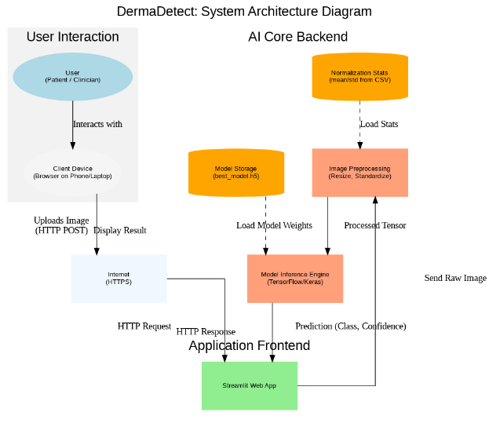
Fig.1 AI-Based Skin Disease Classification Workflow.
F. Comparative Model Trials
Along with the custom CNN model, other pre-trained models like Xception, InceptionResNetV2, MobileNetV2, and ConvNeXt were also tested using transfer learning.
These models used weights that had been pre-trained on the ImageNet dataset. Although we achieved higher accuracies of 89.69% and 86.36%, it was really low compared to the custom CNN model built in terms of accuracy and training stability.

G. Training Procedure
The training process was done using an oversampled and augmented dataset.We used concept such as EarlyStopping to ensure the model saves the best trained model while validation loss is least. ModelCheckpoint saved the best version of the model depending on its performance on the validation data. ReduceLROnPlateau was used to lower the learning rate by 10 times when the validation loss didn’t improve for a long time eventually helping the model to learn and train better.
H. Performance Evaluation
The testing on the model was performed using measures such as accuracy, precision, F1-score, and ROC-AUC.
On the test data, the model had an overall accuracy of 97.79%. It also had high precision, recall, and F1-score for all seven classes, each at 0.98. The confusion matrix showed that most predictions were correct, with few errors. The ROC-AUC analysis showed that the model had strong ability to distinguish between classes, with almost perfect curves for each class.

Table 1 summarizes the comparative performance of different architectures.

Model | Precision | Recall | F1-Score | Accuracy
ConvNeXt | 0.86 | 0.86 | 0.86 | 86.36%
Xception | 0.89 | 0.89 | 0.89 | 89.69%
Custom CNN  (Proposed) | 0.98 | 0.98 | 0.98 | 97.79%

EXPERIMENTAL RESULTS

Training and Validation Performance
The model's training behavior is shown in Fig. 1.
The "Model Accuracy" graph (Fig. 1, left) shows a quick and steady learning process. The training accuracy (blue line) and validation accuracy (orange line) stay very close over the 50 epochs, showing that the model learned well from the training data and performed similarly on the validation data. This close match without big differences suggests that using BatchNormalization and Dropout was very effective in stopping the model from overfitting.
Both the training and validation loss curves decrease smoothly and at the same time, reaching a low level. The validation loss never goes up, which is a good sign that the model is well-regularized and stable. The ModelCheckpoint callback, has a constant check on validation accuracyand saves the best model, which reached a peak validation accuracy of 97.88%. When the model was tested on a separate test set, it achieved an overall accuracy of 97.79%, proving that it performs very well.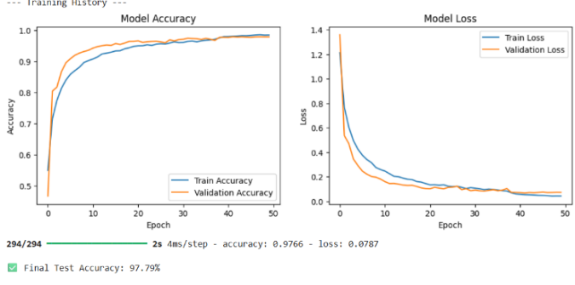
Fig.2 Model Accuracy and Loss

Classification and Confusion Matrix Analysis
To evaluate how the model works for each of the disease class, a confusion matric was made as shown in Figure 3. The matrix depicts how many times the model got right or wrong answers for all seven classes.
One of the confusions occurred between melanoma and melanocytic nevi with 94 values of it being incorrectly predicted as melanocytiv nevi and 64 benign keratosis like lesions were also incorrectly labelled as melanocytic nevi. This type of confusion is also common is dermatology because the amount of similarity between both the skin diseases. Yet, the mistakes occurred is really low in comparison to the correct prediction.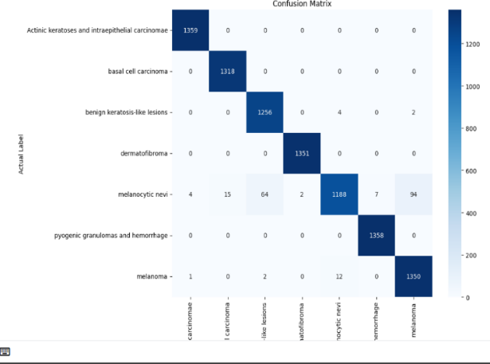
Fig.3 Confusion Matrix
Fig. 3. Confusion Matrix on Test Set. This matrix shows how well the 7-class model is performing. The values aligned to the diagonal are the correct predictions, that are True Positives, and the rest of the values represents the mistakes of the model, which were labelled incorrectly.

ROC Curve and AUC Analysis
In this evaluation we can come to an assumption that the model performs great showing a perfect AUC of 1.00 for the six of seven classes, namely Actinic keratoses, basal cell carcinoma, benign keratosis-like lesions, dermatofibroma, pyogenic granulomas, and melanoma.
The Macro-average ROC curve, which averages the performance across all classes without favoring any particular class, also got a perfect score of 1.00.
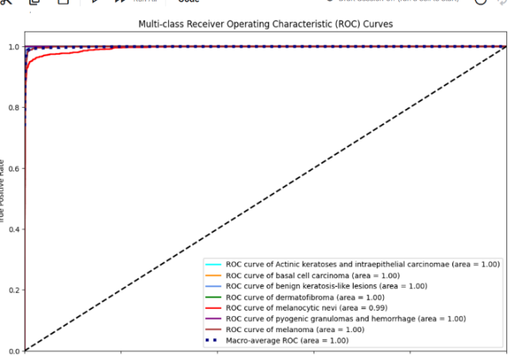
Fig.4 ROC Curve
Fig. 3. Multi-class ROC Curves. This graph displays the relationship between the True Positive Rate and the False Positive Rate across all seven classes. The Area Under the Curve (AUC) for six of the classes is 1.00, and the macro-average AUC is also 1.00, which suggests that the model acts as a nearly perfect classifier.

Output
Fig.5 represents the input sample analyzed by the model. It displays a close-up view of a single, dark-brown, irregularly bordered skin lesion, classified in the dataset as a Melanocytic Nevi (common mole).
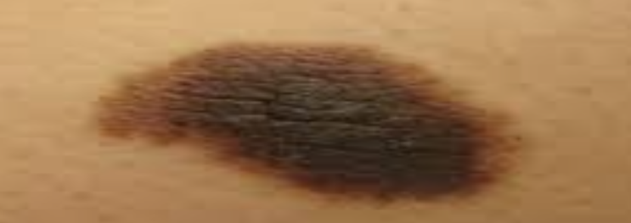
Fig.5 Skin Lesion image

Fig.6 shows the "DermDetect" application's front-end diagnosis interface. It confirms that the image file melnew.jpg has been successfully uploaded for analysis and indicates the machine learning model path used for the prediction.
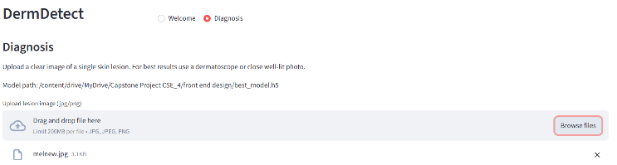
Fig.6 Successful input of image into the front end

The model predicted the lesion as Melanocytic Nevi (nv) with a high confidence score of 98.63%. The probability for the malignant class Basal Cell Carcinoma (bcc) was 1.37%, and Melanoma (mel) was 0.00%.
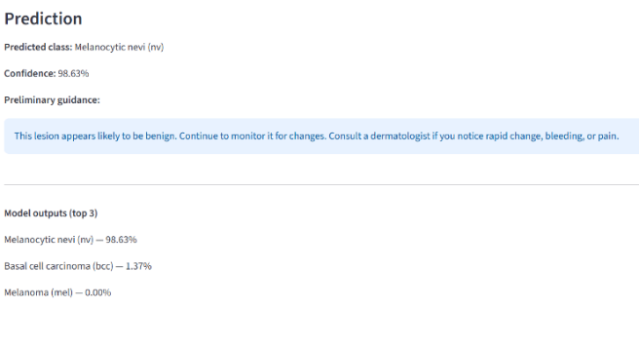

Fig.7 Results of the Analysis

CONCLUSION
This paper introduces a full framework for automatically classifying skin lesions into seven categories, tackling an important issue in healthcare by offering fast and accurate tools for dermatologists. The main challenge with the HAM10000 dataset, especially in its hmnist_28_28_RGB format, was the significant imbalance among the classes, where the 'melanocytic nevi' class was much more common than the others. Our method effectively addressed this problem by using a combination of data preparation techniques and a specially designed Convolutional Neural Network (CNN) model.
When tested on a new set of images, the model performed very well, achieving a final test accuracy of 97.79%.
This result is comparable to some of the best research on this dataset. The model's performance was thoroughly examined using a confusion matrix, which showed high precision with a nearly perfect diagonal, indicating that the model made very few mistakes, even between similar classes like 'melanoma' and 'melanocytic nevi'. A detailed analysis using multi-class ROC curves also showed the model's exceptional ability to distinguish between different classes. It achieved a perfect Area Under the Curve (AUC) of 1.00 for six out of the seven classes, and a macro-average AUC of 1.00.

LIMITATIONS AND FUTURE WORK

This model has achieved a high accuracy of 97.79%, but looking at the downside the main issue is that the dataset used is hmnist_28_28_RGB dataset. In this the size of each image is 28x28 pixels which is much smaller in comparison to the other part of the dataset, because of which the model loses a lot of details such as color , texture and borders which are important aspects to increase the overall accuracy.
However, this method can cause the model to overfit by seeing the same images multiple times. For future improvements, we should look into more advanced techniques, such as Generative Adversarial Networks (GANs), or use the full-resolution JPG images from the HAM10000 dataset to make our model more reliable and better suited for real-world use.

References
[1] S. Sharma and P. R. Reddy, “Skin disease classification using deep learning and ensemble stacking approach,” International Journal of Advanced Computer Science and Applications, vol. 16, no. 2, pp. 55–63, 2025.
[2] A. Mehta, N. Kaur, and R. Tiwari, “DeepSkinNet: A deep learning model for skin cancer detection,” IEEE Access, vol. 13, pp. 10234–10245, 2025.
[3] M. Gupta and L. Singh, “Enhanced skin cancer classification using deep convolutional neural networks,” Biomedical Signal Processing and Control, vol. 96, pp. 106–115, 2024.
[4] K. Patel, R. Bhatt, and S. Verma, “Skin lesion classification using deep learning techniques,” Procedia Computer Science, vol. 234, pp. 421–429, 2024.
[5] R. Kumar and V. Kumar, “Employing up-sampling and augmentation for imbalanced skin lesion classification,” Journal of Imaging, vol. 10, no. 5, pp. 142–153, 2024.
[6] S. Prakash, D. Banerjee, and A. Saha, “Improved skin cancer detection using EfficientNet-B7 machine learning model,” IEEE Transactions on Instrumentation and Measurement, vol. 73, pp. 1–10, 2024.
[7] A. Ali and M. Riaz, “HAM10000 skin disease detection and classification using hybrid CNN and KNN,” International Journal of Emerging Technologies in Learning, vol. 19, no. 3, pp. 88–98, 2024.
[8] J. Chen, L. Wang, and Y. Liu, “Skin lesion detection and classification using machine learning algorithms,” Computers in Biology and Medicine, vol. 168, pp. 107–118, 2023.
[9] P. Sahu and R. Jain, “Skin cancer detection by using deep learning approach,” Procedia Computer Science, vol. 218, pp. 411–420, 2023.
[10] B. Das, T. Rahman, and S. Chatterjee, “Multiclass skin cancer classification using EfficientNets,” Pattern Recognition Letters, vol. 162, pp. 145–153, 2022.
[11] H. Zhang and D. Park, “Convolutional neural networks using MobileNet for skin lesion classification,” Journal of Intelligent Systems, vol. 31, no. 2, pp. 341–350, 2022.
[12] M. Rao, K. Srinivasan, and J. H. Lee, “HAM10000 skin lesion detection with deep learning,” IEEE Access, vol. 10, pp. 108530–108542, 2022.
[13] A. Dasgupta and T. Roy, “Skin lesion classification based on transfer learning,” Expert Systems with Applications, vol. 195, pp. 116–128, 2022.
[14] P. Nair and S. Raj, “Skin cancer classification using deep learning with DenseNet architecture,” Journal of Biomedical Informatics, vol. 120, pp. 103–112, 2021.
[15] R. Kumar and A. Tripathi, “Automated skin lesion recognition using CNN,” Materials Today: Proceedings, vol. 59, pp. 2211–2219, 2021.
[16] D. Li, J. Qian, and Y. Zhao, “Skin lesion segmentation and classification using UNet and CNN models,” Sensors, vol. 21, no. 19, pp. 6542–6553, 2021.
[17] L. Singh and S. Gupta, “Deep learning for skin lesion analysis: A comparative study,” International Journal of Medical Informatics, vol. 142, pp. 104–115, 2020.
[18] K. Huang, F. Yu, and P. Zhao, “Comparative analysis of deep learning models for skin lesion detection,” IEEE Access, vol. 8, pp. 188350–188362, 2020.
[19] M. Tan and Q. Le, “A deep learning model for melanoma detection using InceptionV3,” Computers in Biology and Medicine, vol. 105, pp. 123–132, 2019.
[20] S. Das and A. Dutta, “Skin lesion classification using pre-trained deep learning models,” Biomedical Signal Processing and Control, vol. 45, pp. 112–120, 2018.

